3. Project Design Phase
Project: Implement Client Script & UI Policy (ServiceNow)

Phase Objective
The design phase converts the requirements into a practical ServiceNow form design. Navigation, tables, fields, form layout, and the locations where Client Scripts and UI Policies will be applied are identified.

Activities Covered
- Identify the ServiceNow form and relevant fields.
- Plan where Client Script and UI Policy rules will be applied.
- Arrange the form behavior according to the requirements.

Screenshots from the Project Video
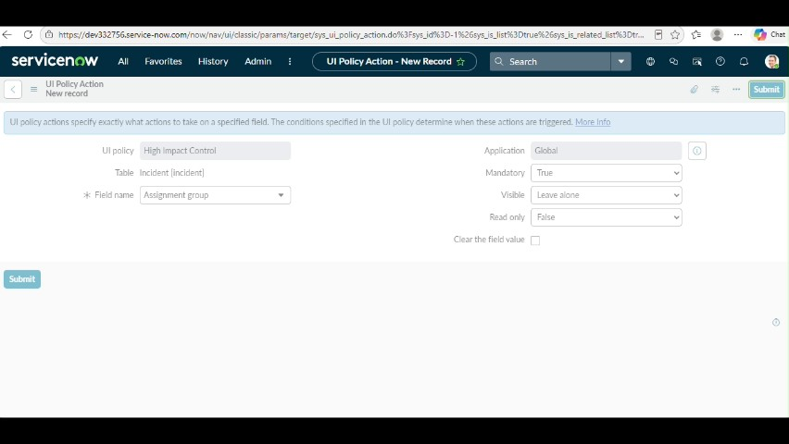
Figure 1: Project video screen at approximately 92 seconds.
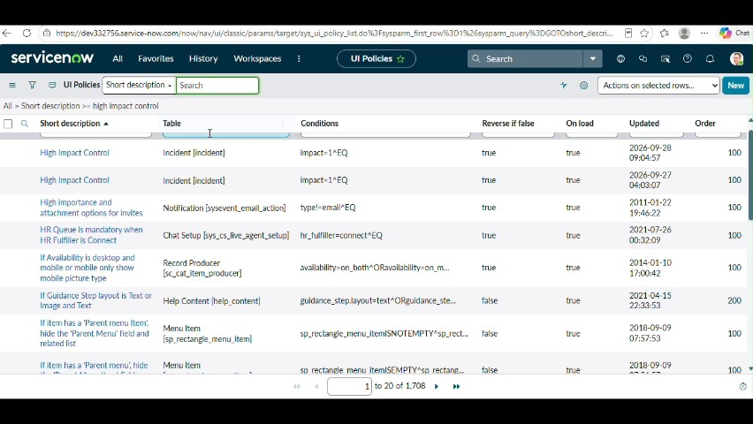
Figure 2: Project video screen at approximately 108 seconds.
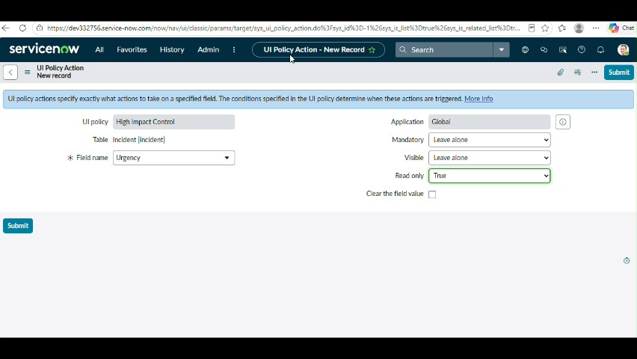
Figure 3: Project video screen at approximately 126 seconds.
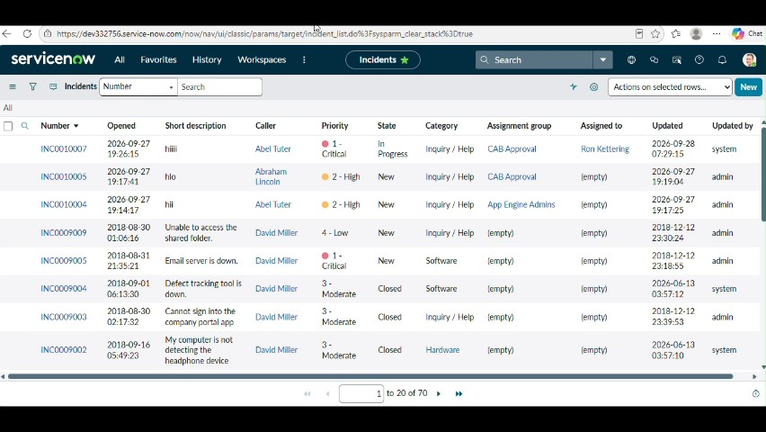
Figure 4: Project video screen at approximately 139 seconds.
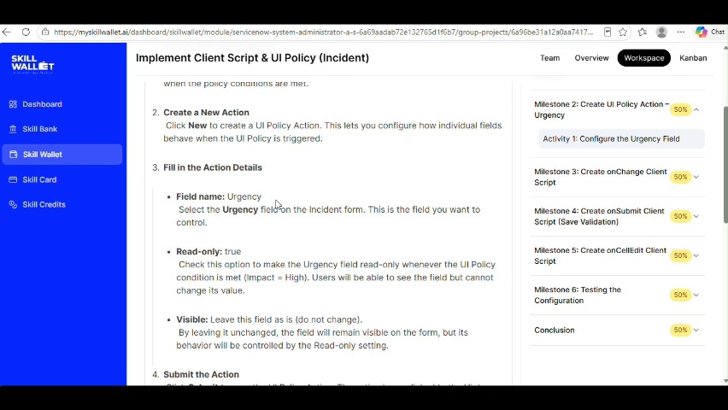
Figure 5: Project video screen at approximately 149 seconds.

Phase Outcome
A practical design is established for the ServiceNow form and its Client Script/UI Policy behavior.
Prepared from the supplied project demonstration video

